Project Design Phase
Solution Architecture

Date | 08 October 2026
Team ID | 9100Quadra
Project Name | Auto Ticket Classification Using ServiceNow Flow Designer
Maximum Marks | 4 Marks

Solution Architecture:
Solution architecture bridges the gap between business problems and technology solutions. Its goals are to:
- Find the best technical solution for the manual classification problem.
- Describe the structure and behaviour of the solution to project stakeholders.
- Define features, development phases and solution requirements.
- Provide specifications according to which the solution is defined, managed and delivered.
Solution Architecture Diagram:
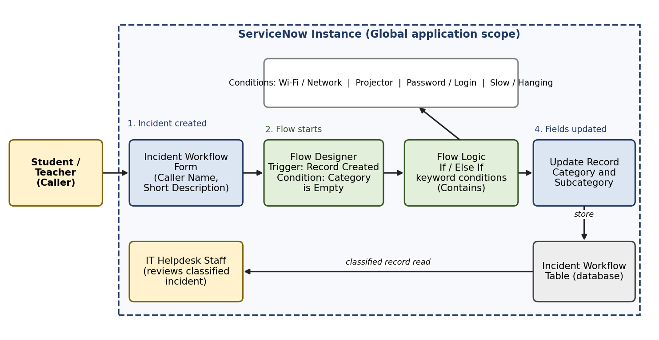
Figure 1: Architecture and data flow of the Auto Ticket Classification solution
Flow of execution: (1) the caller creates an incident; (2) ServiceNow stores the record in the Incident Workflow table; (3) the Flow Designer trigger Record Created fires when Category is Empty; (4) Flow Logic evaluates the Short Description with If / Else If conditions; (5) the Update Record action sets Category and Subcategory; (6) helpdesk staff review the classified incident.

